Layout Overrides in Joomla

De Joomla! Documentation

Esta página contém alterações que não estão marcadas para tradução.

This Article Needs Your Help
This article is tagged because it NEEDS REVIEW. You can help the Joomla! Documentation Wiki by contributing to it.
More pages that need help similar to this one are here. NOTE-If you feel the need is satistified, please remove this notice.
Split Page into Specific Joomla! Versions - J2.5 and 3.x
It has been suggested that this article or section be split into specific version Namespaces. (Discuss). If version split is not obvious, please allow split request to remain for 1 week pending discussions. Proposed since 19 days ago.
This tutorial is for Joomla! CMS Version(s)

Índice
- 1 Introduction to Alternative Layout Feature in Versions 2.5+
- 2 Module Alternative Layouts
- 3 Plugin Alternative Layouts (Overriding a Plugin)
  - 3.1 Plugin Override example
- 4 Component Alternative Layouts
- 5 Category Alternative Layouts
- 6 Drill Down to Blog or List
- 7 Alternative Menu Items
- 8 Controlling the Template for Alternative Menu Items
- 9 JLayout Micro-Layout Overrides
  - 9.1 Creating a new JLayout that only appears on some pages
- 10 Further Reading

Introduction to Alternative Layout Feature in Versions 2.5+
Joomla! 1.5 introduced the concept of overriding core layouts using the template override system. Joomla! version 2.5 introduces a set of features that give the site administrator more control over the display of articles, contacts, news feeds and Web links. There are five types of alternative layouts:
- Module
- Component
- Category
- Menu Item
- JLayouts
Alternative layouts work in a similar fashion to the template override feature but allow you more options and control. Each type is discussed below.

Module Alternative Layouts
Creating an alternative layout for a module is similar to creating a template override for a module. In both cases, you create a folder called templates/<your template>/html/<module name>. For example, the folder for a "mod_login" template override or alternative layout for the beez5 template would be templates/beez5/html/mod_login/.
There are two important differences between a template override and an alternative layout. The first is the file name. For the template override, you would call the file default.php to match the core file name. For an alternative layout, you use a different name. The only rule is that the file name should not have any underscores in it. This allows you to have complex layouts that include multiple files. The initial file to be called is named without underscores and any other files that are called from this initial file will have underscores in the name. For example, you could have the initial file called mynewlogin.php which calls mynewlogin_1.php.
The second important difference is that, unlike template override files which are called automatically whenever the module is displayed using the template with the override, an alternative layout file is only called if you select it as a parameter in the Module Manager. In version 2.5 and later, there is a new parameter under Advanced Options called Alternative Layout, as shown below.
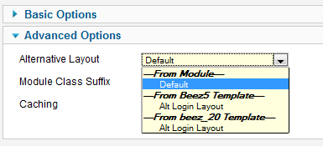
This parameter will list any files (without underscores) that you have placed in the template folder for this module. You can also translate the file name using the template's system language file. For example, if you add the line
TPL_BEEZ5_MOD_LOGIN_LAYOUT_NOLOGIN="Alt Login Layout"
to the file en-GB.tpl_beez5.sys.ini, it will translate the file name nologin.php to "Alt Login Layout".
It is important to understand that if specified in the Module Manager screen, an alternative layout file for a module will be used for that module regardless of what template is used to display the page where the module is shown. It is therefore the administrator's responsibility to make sure that the layout file will work as desired in any templates where this module may be shown.

Plugin Alternative Layouts (Overriding a Plugin)
Yes, it's possible to override plugin outputs. It's very useful, especially for content plugins. However you can only do it if the plugin is ready to allow overrides.
A Tip!
Joomla provides a mechanism to override a plugin but this feature is not supported by all the plugins
Right now the only plugin in Joomla 3.x core that allow overrides is the Pagenavigation Content plugin that shows previous/next article links in article view of content component. There may be other plugins from third party developers allowing it and more core plugins will be overridable in the future.
You will know when a plugin is overridable because has a /tmpl/ folder in it. See: https://github.com/joomla/joomla-cms/tree/staging/plugins/content/pagenavigation (note for developers: the plugin uses JPluginHelper::getLayoutPath() )

Plugin Override example
To override the output of Pagenavigation content plugin in "beez3" template, create a folder named templates/beez3/html/plg_content_pagenavigation/ and copy the original layout file (plugins/content/pagenavigation/tmpl/default.php) to this new folder.
Now you can change this layout file to override plugin output.
Is important to note that to build the override layout you need to create it in this path:
templates/TEMPLATE-NAME/html/plg_PLUGIN-GROUP_PLUGIN-NAME/
example: templates/beez3/html/plg_content_pagenavigation/
Where PLUGIN-GROUP is the group to which the plugin belongs. (It is the name of the first folder where the plugin is located. See: https://github.com/joomla/joomla-cms/tree/staging/plugins. Read more about Event groups at Plugin/Events)

Component Alternative Layouts
Component alternative layouts work similarly to module layouts discussed above. Again, a file is placed in the same folder where you place a template override file. For example, to create an alternative layout for an article for the template "beez5", you would put a file in the folder templates/beez5/html/com_content/article/. As with module layouts, the file must not be named the same as the core file and must not include underscores in the name. Additionally, there should not be an XML file of the same name in this folder. (We'll discuss XML files below under Menu Item Alternative Layouts.)
You can set a global value for component layouts in the Options window of the component. For example, in the Article Manager Options window, there is a parameter for Alternative Layout as shown below:
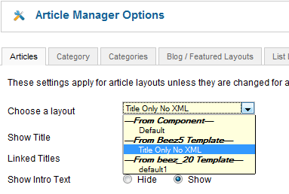
This will create a global value that individual components (articles, contacts, news feeds and Web links) can inherit from.
As with module layouts, the component layouts are shown as parameter options in the individual component edit screen. For example, for an article, the parameter shows in the Article Options group as shown below.
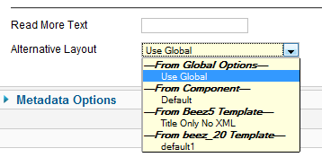
As with other parameters, the Use Global setting will use the setting from the Options parameter. The From Component's Default setting will use the component's default layout. Alternative layouts that you have created for different templates are shown under each template heading.
File names may be translated. The line below:
TPL_BEEZ5_COM_CONTENT_ARTICLE_LAYOUT_MYLAYOUT="Title Only No XML"
will translate a file called "mylayout.php" as "Title Only No XML".
You can have more than one file for a layout. The initial file must be named without underscores and any additional files must have underscores.
Component alternative layouts may be used with articles, contacts, or news feeds. Web links don't have a single-component layout so no alternative layout is available for Web links.
Component alternative layouts are only used when two conditions are met: (1) they are specified in the component parameters; and (2) there is no menu item for this specific component. For example, if you have one or more menu items of type "Single Article" set up for a given article, then the alternative layout for that article will not be used. Instead, the layout specified in the menu item will be used. This is consistent with the general way that component parameters work, where the most specific (in this case a single-article menu item) overrides the less specific (in this case, the article parameters).

Category Alternative Layouts
Category alternative layouts work identically to component layouts. The rules for specifying layout files are the same. The only difference is that the folder is the category folder, not the component folder. For example, a contact category alternative layout for beez5 would go in the folder templates/beez5/html/com_contact/category.
You can set category layouts globally, in the Options screen of each component. Below is an example from the Contact Manager Options screen:
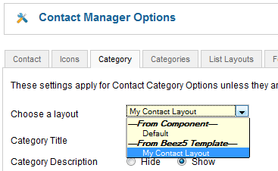
Category alternative layouts show up when you add or edit a category in the Category Manager under the Basic Options as shown below.
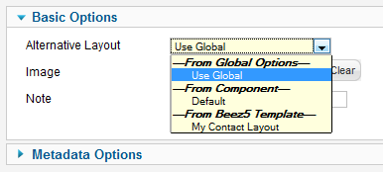
Category alternative layouts may be used for articles, contacts, news feeds and Web links.
As with component layouts, category layouts only will show if (1) they are specified for the category in the global or category parameters and (2) there is no menu item specifically for this category (for example, List Contacts in a Category, List News feeds in a Category, List Web links in a Category, Category List, Category Blog).
If there is a menu item set up for this specific category, that layout will be used instead of the alternative category layout.

Drill Down to Blog or List
For articles, we have two core layouts available: Blog and List. Both of these options show under the "From Component" heading in the layout parameters for article category. So, like other layout options, you can now select Blog or List for categories either globally (in the Article Manager Options, shown below), or when editing a single article category.
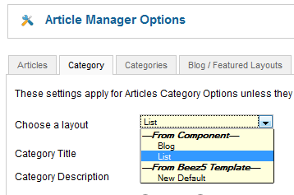
This means that, like other layout options, you can control whether article category links drill down to blog or list layouts. It is important to understand that, like other layout parameters, this option will only take effect when there is no single-category menu item for the category.

Alternative Menu Items
Alternative Menu Items have one important difference with the others. To create a menu item alternative layout, you must include an XML file whose name matches the initial layout file. For example, to create an alternative menu item called "myarticle" for an article in the beez5 template, you would create two files in the templates/beez5/html/com_content/article folder called myarticle.php and myarticle.xml. If you wanted to include more layout files, you would add these files with underscores in the file names.
The XML file uses the same format as the core Menu Item XML files. This allows you not only to create a customized layout for this menu item but also allows you to create customized parameters. For example, you could hide some parameters or add new parameters.
Alternative Menu Items show up when you select a menu item type in the Menu Manager as shown below.
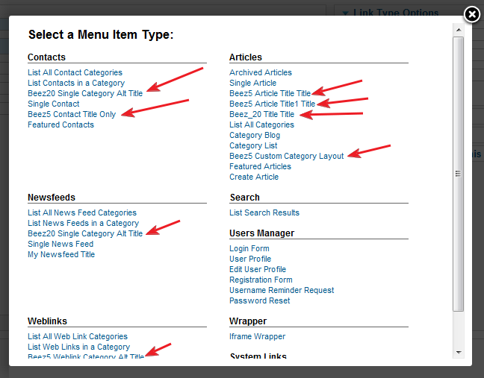
Alternative Menu Items are used and work the same way as standard menu items. Since they are already based on customized layouts, template overrides do not apply to alternative menu items.
As indicated above, menu item layouts take priority over component or category alternative layouts.
Translation of alternative menu items is done with the following tags in the XML files. The format is "TPL_"<template name>_<component>_<view>_<menu item name>_<tag type>. For example, these lines below will translate the title, option, and description for an alternative menu item called "catmenuitem".
TPL_BEEZ5_COM_CONTENT_CATEGORY_VIEW_CATMENUITEM_TITLE="Beez5 Custom Category Layout"
TPL_BEEZ5_COM_CONTENT_CATEGORY_VIEW_CATMENUITEM_OPTION="Beez5 Custom"
TPL_BEEZ5_COM_CONTENT_CATEGORY_VIEW_CATMENUITEM_DESC="Description for beez5 custom category layout."
These strings have to be added to language/en-GB/en-GB.tpl_beez5.sys.ini
The catmenuitem.xml would start with:
<?xml version="1.0" encoding="utf-8"?>
<metadata>
<layout title="TPL_BEEZ5_COM_CONTENT_CATEGORY_VIEW_CATMENUITEM_TITLE" option="TPL_BEEZ5_COM_CONTENT_CATEGORY_VIEW_CATMENUITEM_OPTION">
<help
key = "JHELP_MENUS_MENU_ITEM_ARTICLE_SINGLE_ARTICLE"
/>
<message>
<![CDATA[TPL_BEEZ5_COM_CONTENT_CATEGORY_VIEW_CATMENUITEM_DESC]]>
</message>
</layout>

Controlling the Template for Alternative Menu Items
As discussed above, the presence of an XML file makes an alternative layout a menu item. The format of the XML file is the same as the format for core menu item XML files. With this XML file, you can add the parameters you wish to include for this menu item. They can be the same as one of the core menu items, or you can omit core parameters or add new ones. Note that if you add new parameters, these can be used in the layout file but will not be used in the core model or view files.
It is also possible to override parameter settings for core parameters. One example of this is to control which templates an alternative menu item layout can be displayed with. In some cases, you may want to allow a custom menu item to be displayed with any template for the site. In other cases, you may wish to limit that menu item's layout to one specific template. In this situation, you would just add the following parameter to the menu item's XML file:
<fields>
<field
name=''"template_style_id"''
type=''"templatestyle"''
label=''"COM_MENUS_ITEM_FIELD_TEMPLATE_LABEL"''
description=''"COM_MENUS_ITEM_FIELD_TEMPLATE_DESC"''
filter=''"int"''
template=''"beez5"''
class=''"inputbox"''>
</field>
</fields>
This will override the core template_style_id parameter. Setting the template equal to "beez5" in this case will limit the user to only selecting template styles for the "beez5" template.

JLayout Micro-Layout Overrides
JLayouts is a powerful feature of Joomla! JLayouts can be loosely defined as micro-layouts. They are the micro-layouts for individual elements of Joomla! pages. For example, the read more button, the intro image, the full image, are all examples of elements that are controlled via own JLayout.
If we dig deeper into the Category Blog Layout view, you will find the code to call the article title, an intro image, the intro text, as well as various other relevant parts of the page. This is what it looks like when you call an element using JLayout.
<?php echo JLayoutHelper::render('joomla.content.blog_style_default_item_title', $this->item); ?>
This particular bit of code calls the Article Title within the Joomla! Category Blog.
To help you to understand the location of the file for this particular element, it would help to understand that there is a naming convention in play. Looking at joomla.content.blog_style_default_item_title the dots can be replaced with /'s to understand the directory structure. All JLayouts are initially found in JOOMLAROOT/layouts. Using the naming convention we can see that this file will be located in JOOMLAROOT/layouts/joomla/content/blog_style_default_item_title.php.
Let's go through an example. For this example, we will move the intro image to above the title, you could also add some additional structure around it if you wanted.
You should not edit JLayout files directly as changes would be overwritten during any core upgrade. The correct way to update the JLayout is by finding the element you want to override (such as intro_image), and copying the file to your template. You should then copy the folder structure of the element that you want to override that exists within the layouts folder within the Joomla! parent directory e.g. templates/YOUR_TEMPLATE/html/. You only want to copy the file(s) that you require to avoid site bloat, and to minimise the probability of causing an issue.
An example for the intro_image would be originally found in: JOOMLAROOT/layouts/joomla/content/intro_image.php
The copied file would be: templates/YOUR_TEMPLATE/html/layouts/joomla/content/intro_image.php
As a simple example let's add a responsive image class to the intro image. First of all, we open our copied JLayout file, which we just placed in templates/YOUR_TEMPLATE/html/layouts/joomla/content/intro_image.php.
Look for the following line
<div class="pull-<?php echo htmlspecialchars($imgfloat); ?> item-image">
Let's add our responsive image class img-responsive to the existing classes.
<div class="pull-<?php echo htmlspecialchars($imgfloat); ?> item-image img-responsive">
Ok, we have added our class. Let's save and close the file. Ensure it is uploaded to our website. Now if we refresh the page we will see the class img-responsive on our intro images. You have just used a JLayout, think of all the other great things you could do with JLayouts?

Creating a new JLayout that only appears on some pages
You can also create new JLayout files. They do not need to be based on existing elements. Simply add them into the YOUR_TEMPLATE/html/layouts/ directory as above and Joomla! will be able to find them. Then you need to reference the new JLayout in your code. For simplicity, in this example, I have duplicated an existing element, and made my own version.
I will start by doing a standard HTML template override for the Blog layout (not a JLayout override). You can find out how to do this further up this page. Doing a template override will add a few files to my templates/YOUR_TEMPLATE/html folder. I will create a new JLayout which I only want to use on my blog view. If I simply edited the JLayout for intro_image it would effect all of my intro_images, but I only want to alter my Category Blog View intro_images.
The file I want to use is templates/YOUR_TEMPLATE/html/com_content/category/blog_item.php. Within that file I find the line <?php echo JLayoutHelper::render('joomla.content.intro_image', $this->item); ?> which is calling a JLayout element. That particular code is for the intro_image element.
For the sake of simplicity I copied the file JOOMLAROOT/layouts/joomla/content/intro_image.php. I put it in templates/YOUR_TEMPLATE/html/layouts/joomla/content/ and I renamed it intro_image_blog.php.
Now I open my template override file templates/YOUR_TEMPLATE/html/com_content/category/blog_item.php. I find the reference to <?php echo JLayoutHelper::render('joomla.content.intro_image', $this->item); ?>, I remove it, I reposition the JLayout above the title, and I use my own JLayout that I just created templates/YOUR_TEMPLATE/html/layouts/joomla/content/intro_image_blog.php .
Now my new JLayout is being used, and it has been positioned above the title. I can now make further amendments such as adding a responsive image class if need be and changes will only be reflected in the Category Blog View.

Further Reading
You can find further reading here https://docs.joomla.org/J3.x:Sharing_layouts_across_views_or_extensions_with_JLayout

How to override the output from the Joomla! core

De Joomla! Documentation

Outros idiomas:
български • ‎English • ‎español • ‎français • ‎Nederlands
There may be occasions where you would like to change the way a Joomla! Extension (such as a Component or Module, whether from the Joomla! core or produced by a third party) is displayed on your site. Of course, you could recode the Extension from scratch, but that may be a bit ambitious for you! Thankfully, there is another way.
The standard output from any Joomla! Module or Component can be overridden by adding code to the html directory of your template. It is also possible to override two aspects of core functionality: Module chrome, and pagination.
As of overrides can be created using the Template manager Creating Overrides

Getting a head-start with overrides
If you are new to Joomla! development, then it is probably easiest to start with an existing view, and try modifying it to get what you want. To do this, you should make a copy of the existing view in the html directory of your template, and then modify the copy.
The directory structure you need is:
TEMPLATE_NAME/html/EXTENSION_NAME/VIEW_NAME/FILE_NAME.php
For example, if you want to change the way that the 'Article' view displays a com_content article, then you should copy the file at :
PATH_TO_JOOMLA/components/com_content/views/article/tmpl/default.php
to
TEMPLATE_NAME/html/com_content/article/default.php
(note the slight difference in directory structure)
Similarly, if you want to change how the mod_login Module is displayed, then you should copy :
PATH_TO_JOOMLA/modules/mod_login/tmpl/default.php
to
TEMPLATE_NAME/html/mod_login/default.php
Joomla! comes pre-packaged with a frontend template called Beez. Beez utilizes template overrides to produce a table-less layout for faster, smoother, and semantically correct markup. To see how it's done, locate your Joomla! installation's template directory, and you'll notice the Beez template. Inside the Beez template directory, you'll find a directory named html.
The entire directory structure is as follows:
/your_joomla/templates/Beez/html/
If you want to try modifying the overrides used in Beez, you could simply copy and paste the Beez html directory into your own template's main directory. However you choose to make your override files, you will need to ensure that they are correctly installed with your template. To do this, you should add the following code to your template's templateDetails.xml file (in between the <files> and </files> tags):
<folder>html</folder>
The above code in essence lets the Joomla! package installer know that there are files to extract, and that they are part of the template as a whole.

Further tips
You can override Joomla's core images that are stored in the /media/ folder. Put an alternative image with the same name in your template folder. For example, the Breadcrumbs Module uses an orange arrow that is retrieved from /media/system/images/arrow.png. Joomla will use your override version if you put it at /templates/your_template_name/images/system/arrow.png.
Template overrides are almost limitless. They allow you to add, edit, and remove the components of the Joomla! core output. The Template Manager can be used to create override files ready for editing.
Note: For the FireFox web browser, an extension called Firebug is available, which is useful for browsing a page's HTML source and matching it up with the PHP code used in template overrides. For more information, please watch the free video tutorial on using Firebug with Joomla. Now firebug is also available for IE called Firebug Lite.
More information is available from the following resources:
- The article Understanding Output Overrides explains the theory behind template overrides.
- The preferred way of changing text output is by using translations in your template.
- A downloadable tutorial is also available.
- Example in github how to override layout of view without override the view, but extending it.
- j-over.de has a huge collection of overrides to use for your own templates.

Understanding Output Overrides

De Joomla! Documentation

This tutorial is for Joomla! CMS Version(s)
This was a Developer Blog post by Andrew Eddie, initially copied to the wiki with minor edits by Alan Langford.

Índice
- 1 Introduction
- 2 MVC 101
  - 2.1 Template versus Layout
  - 2.2 Ancillary Customisation
  - 2.3 Ancillary Customisation:Chrome
  - 2.4 Ancillary Customisation:Pagination
- 3 Component Output Types and Layout Overrides
  - 3.1 Output Types
  - 3.2 Layouts
  - 3.3 Copying or Creating Layout Files
  - 3.4 Overriding Sub-Layouts
- 4 Module Layout Overrides
  - 4.1 Copying or Creating Layout Files
- 5 Module Chrome
- 6 Pagination Links Overrides
- 7 Media Files Override
  - 7.1 Supporting Media Files Override
- 8 Cheat Sheet
  - 8.1 Customise the Component Output
  - 8.2 Customise the Module Output
  - 8.3 Add New Module Styles
  - 8.4 Customise the Pagination Links
- 9 Conclusion

Introduction
There are many competing requirements for Web designers ranging from accessibility to legislative to personal preferences. Rather than trying to over-parameterise views, or trying to aim for some sort of line of best fit, or, worse, sticking its head in the sand, Joomla! has added the potential for the designer to take over control of virtually all the output that is generated.
Joomla! has been criticized by some for not giving due attention to accessibility or being archaic in their approach to Web standards. However, with 1.5, the responsibility--and, more importantly, the power--to control output is back in the designer's hands.
In addition, except for files that are provided in the Joomla! distribution itself, these methods for customisation eliminate the need for designers and developers to "hack" core files that could change when the site is updated to a new version. Because they are contained within the template, they can be deployed to the Website without having to worry about changes being accidentally overwritten when your System Administrator upgrades the site.
The aim of this tutorial is to introduce the fours areas of the output of Joomla! that are able to be customised by the template designer.
Not interested in all the theory? Jump straight to the cheat sheet below.

MVC 101
MVC can be a scary acronym. It stands for Model-View-Controller and the concepts behind MVC are responsible for the extra flexibility that is now afforded to the designer. While parts of the theory can be rather involved and complicated, the only part that the designer need worry about is the V for View. This is the part that is concerned with output.
Different extensions display output in different ways.
Components, as you already know, are fairly complex and have the ability to display different information in different ways. For example, the Articles Component (com_content) is able to display a single article, or articles in a category, or categories in a section. Each of the ways of representing the different types of data (an article, or a category, or a section) is called a "view" (this comes from our MVC terminology). Most components will have many views. However, the view doesn't actually display the output. This is left up to what we call a "layout" and it is possible for a view to have a variety of layouts.
The main thing to remember here is that components can have multiple views, and each view can have one or more layouts. Each view assembles a fixed set of information, but each layout can display that information in different ways. For example, the Category view in the Articles component assembles a number of articles. These articles could be displayed in a list or in a table (and probably other ways as well). So this view may have a "list" layout and a "table" layout to choose from.
Modules, on the other hand, are very simple. They generally display one thing one way. Modules don't really have views but they do support a layout. Some developers might even support a choice of layout through module parameters.

Template versus Layout
It is very important to distinguish between the role of templates and the role of layouts. The template sets up a structural framework for the page of the Web site. Within this framework are positions for modules and a component to display. What actually gets displayed is governed by the module layout, or the combination of view and layout in the case of the component.
The following image shows the structural layout of a typical Joomla! template (rhuk_milkyway, the default for 1.5). The module positions are displayed by adding tp=1 to the URL (eg, index.php?tp=1). You can clearly see where the module output is contained within the overall template, as well as the main component output starting in the lower-centre region. However, what is actually output in those regions is controlled by the layouts.
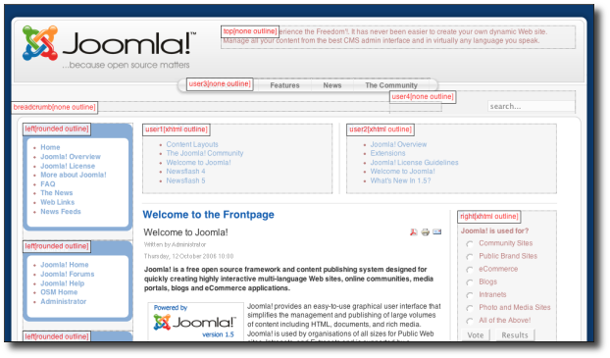

Ancillary Customisation
While not strictly related to the MVC, there are two other important areas to consider when looking at customising the output of Joomla!.

Ancillary Customisation:Chrome
In addition to layouts, modules have what we call "chrome". Chrome is the style(s) with which a module is to display. Most developers, designers and probably some end-users will be familiar with the different built-in styles for modules (raw, xhtml, etc). It is also possible to define your own chrome styles for modules depending on the designer result. For example, you could design a chrome to display all the modules in a particular position in a fancy Javascript collapsing blind arrangement.
In the screenshot above, you can just make out the names of some of the built-in module chrome used (rounded, none and xhtml).
Note the potential plural. A module or component can have multiple chrome styles applied to it. For example, When the global template setting "preview module positions" is enabled and the page is loaded with ?tp=1 at the end of the url the chrome "outline" is added to all modules and the component. This is in addition to their regular chrome styling. The default chrome settings can be found in the template/system/html/modules.php file and additional chrome styles may be added by adding your own modules.php file to your template.
Chrome styles are functions and are written in this manner:
/*
* foobar (outputs foo before module content and bar after)
*/
function modChrome_foobar($module, &$params, &$attribs)
{
echo '<h1>Foo</h1>';
echo $module->content;
echo '<h1>Bar</h1>';
}
Use $module->content to access the content generated by the module. You may access the module parameters and attributes by using the appropriate variables passed to this function.

Ancillary Customisation:Pagination
The second area has to do with controlling the pagination controls when viewing lists of data. We will look at that in more detail later.

Component Output Types and Layout Overrides
To understand layout overrides we must first understand the file structure of a component. While there are many parts to a component, all fulfilling different roles and responsibilities, we want to look just in the /views/ directory. Here is the partial structure for two of the com_content views:
/components
/com_content
/views
/articles
/tmpl
default.php (this is a layout)
form.php (this is a layout)
view.html.php (this is the view that outputs the HTML)
view.pdf.php (this is the view that outputs the PDF)
/category
/tmpl
blog.php (layout)
blog_items.php (a sub-layout
default.php (layout)
view.html.php (HTML view)
view.feed.php (RSS feed)
So what you see here is that under the /views/ directory, each view is placed in a directory of its own. The content component actually has three other views not shown: archive, frontpage and section.

Output Types
Under the /articles/ directory we have a number of files. There is almost always a file called view.html.php. This is what we call the view file, but there can be more than one depending on the type of output to produce. It has a specific naming convention, view.output_type.php, where the output type can be html, feed, pdf, raw or error (for more information see JDocument in the API reference and look in the directory /libraries/joomla/document/). What this means is when we want HTML output for this particular view, the view.html.php file is used. When we want the RSS output, the view.feed.php file is used.
The effect of these different output types is most apparent when the Global Configuration setting for Search Engine Friendly URLs is set to Yes, Use Apache mod_rewrite is set to Yes, and Add suffix to URLs is also set to Yes. When this is done, the site URLs will look something like this:
http://domain/sports.html
http://domain/sports.feed
http://domain/sports/rowing.html
http://domain/sports/rowing.pdf
The exact URL will vary depending on how you set up your site but the point here is to show that sports.html will use the category view's view.html.php file to, and that sports.feed will display the RSS feed for the category using view.feed.php. It should be noted that you cannot currently customise feed or PDF output types. However, you can customise the HTML output type and this is where layouts come into play.

Layouts
Under the view directory there is a /tmpl/ directory in which the layout files reside. Each PHP file in this directory represents a layout. For example, article/tmpl/default.php is the default layout for an article whereas article/tmpl/form.php is the edit form for an article; category/tmpl/default.php is the default layout for a category whereas category/tmpl/blog.php displays the list of article differently.
The relationship between component views and layout is most plainly seen when adding a new menu item. The next screenshot represents the typical display of the New Menu Item page. Having clicked on Articles (which represents com_content), the tree expands to show the list of views and each layout within the view.
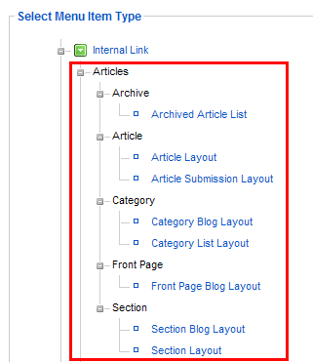
You will notice that while there are extra files in some of the /tmpl/ directories (like pagebreak.php in the article view), they are missing from the list. This is due to instructions in the XML file for the layout (for example, pagebreak.xml) to hide the layout (or even the view) from the menu item list. However, this is another broad topic which will be covered in another tutorial.
Armed with all that knowledge of how all the parts relate to each other, we are now ready to actually create our layout overrides.

Copying or Creating Layout Files
Layout overrides only work within the active template and are located under the /html/ directory in the template. For example, the overrides for rhuk_milkyway are located under /templates/rhuk_milkyway/html/, for the JA Purity template under /templates/ja_purity/html/ and for Beez under /templates/beez/html/.
It is important to understand that if you create overrides in one template, they will not be available in other templates. For example, rhuk_milkyway has no component layout overrides at all. When you use this template you are seeing the raw output from all components. When you use the Beez template, almost every piece of component output is being controlled by the layout overrides in the template. JA Purity is in between having overrides for some components and only some views of those components.
The layout overrides must be placed in particular way. Using Beez as an example you will see the following structure:
/templates
/beez
/html
/com_content (this directory matches the component directory name)
/articles (this directory matches the view directory name)
default.php (this file matches the layout file name)
form.php
The structure for component overrides is quite simple: /html/com_component_name/view_name/layout_file_name.php. Let's look at a few examples.
The rhuk_milkyway template does not have any layout overrides for any components. If we want to override the default layout for an article, first we need to copy this file:
/components/com_content/views/article/tmpl/default.php
to this location, creating the appropriate directories in the event they don't already exist:
/templates/rhuk_milkyway/html/com_content/article/default.php
If we wanted to override the blog layout in the category view, we would copy this file:
/components/com_content/views/category/tmpl/blog.php
to:
/templates/rhuk_milkyway/html/com_content/category/blog.php
Once the files are copied, you are free to customise these files as much or as little as required or desired. You do not have to honour parameter settings if you don't want to.

Overriding Sub-Layouts
In some views you will see that some of the layouts have a group of files that start with the same name. The category view has an example of this. The blog layout actually has three parts: the main layout file blog.php and two sub-layout files, blog_item.php and blog_links.php. You can see where these sub-layouts are loaded in the blog.php file using the loadTemplate method, for example:
echo $this->loadTemplate('item');
// or
echo $this->loadTemplate('links');
When loading sub-layouts, the view already knows what layout you are in, so you don't have to provide the prefix (that is, you load just 'item', not 'blog_item').
What is important to note here is that it is possible to override just a sub-layout without copying the whole set of files. For example, if you were happy with the Joomla! default output for the blog layout, but just wanted to customise the item sub-layout, you could just copy:
/components/com_content/views/category/tmpl/blog_item.php
to:
/templates/rhuk_milkyway/html/com_content/category/blog_item.php
When Joomla! is parsing the view, it will automatically know to load blog.php from com_content natively and blog_item.php from your template overrides.

Module Layout Overrides
Modules, like components, are set up in a particular directory structure.
/modules
/mod_latest_news
/tmpl
default.php (the layout)
helper.php (a helper file containing data logic)
mod_latest_news.php (the main module file)
mod_latest_news.xml (the installation XML file)
Similar to components, under the main module directory (in the example, mod_latest_news) there is a /tmpl/ directory. There is usually only one layout file but depending on who wrote the module, and how it is written, there could be more.
As for components, the layout override for a module must be placed in particular way. Using Beez as an example again, you will see the following structure:
/templates
/beez
/html
/mod_latest_news (this directory matches the module directory name)
default.php (this file matches the layout file name)
The structure for module overrides is again quite simple: /html/mod_module_name/layout_file_name.php.

Copying or Creating Layout Files
The rhuk_milkyway template does not have any layout overrides for any modules. If we want to override the default layout for Latest News module, we need to copy this file:
/modules/mod_latest_news/tmpl/default.php
to this location, creating the approriate directories in the event they don't already exist:
/templates/rhuk_milkyway/html/mod_latest_news/default.php
You need to take a little care with overriding module layout because there are a number of different ways that modules can or have been designed so you need to treat each one individually.

Module Chrome
Joomla! 1.0 had a number of fixed styles that could display a list of modules in a particular position. These where represented by numbers:
- 0 (the default) displayed modules in a vertical table
- 1 displayed them in a horizontal table
- -1 displayed the raw module output
- -2 displayed the modules in a XHTML compatible format with the title in a H3 tag.
- -3 displayed modules in a set of nested DIVs that allowed for rounded-corner techniques
It was a great system except for two things:
- Nobody could remember which number was which, and
- You couldn't expand on the styles.
Well, in 1.5, the numbers are still recognised, but more commonly the style is represented as a word. As well as that, the syntax for displaying a module position was changed. For example, this snippet displays each module in the left position in the xhtml style:
<jdoc:include type="modules" name="left" style="xhtml" />
The built-in styles that are now available are:
- table (was 0 and is the default)
- horz (was 1)
- none (was -1)
- xhtml (was -2)
- rounded (was -3)
- outline (new - used to preview module positions - see screenshot above)
In the source code, these styles are referred to as "chrome". The default chrome is in the system template of the default Joomla! install:
/templates/system/html/modules.php
This file is maintained by the project so you should never modify it. You will lose your changes when you upgrade your Joomla! installation.
To create your own chrome, or module styles, create or edit modules.php under the templates /html/ directory. (This is the same directory we have been talking about for component and module layout overrides).
The rhuk_milkyway template provides some extra chrome as an example. (It provides an example style called "slider"). This can be found in the following file:
/templates/rhuk_milkyway/html/modules.php
Creating your own chrome is easy. Let's look at example that displays the module in a Definition List (a set of DL's, DT's and DD's).
Just add the following function to the /html/modules.php file in your default template directory (create it if it does not exist):
/*
* Module chrome that wraps the module in a definition list
*/
function modChrome_dlist($module, &$params, &$attribs)
{ ?>
<dl class="<?php echo $params->get('moduleclass_sfx'); ?>">
<?php if ($module->showtitle != 0) : ?>
<dt>
<?php echo $module->title; ?>
</dt>
<?php endif; ?>
<dd>
<?php echo $module->content; ?>
</dd>
</dl>
<?php
}
We will be calling the style "dlist", so the name of the function needs to be modChrome_dlist.
The function must take the three arguments as shown for the module object, the module parameters, and lastly the $attribs is an array of all the attributes in the jdoc XML tag.
There are three main properties in the module object to be concerned with:
- showtitle tells you whether to show the title of the module of not
- title is the title of the module
- content is the output of the module (from its layout)
This is a very simple case and you can, of course, design more complex styles, possibly using custom atrributes in the XML tag.

Pagination Links Overrides
The final override we will look at is the pagination override. This override can control the display of items-per-page and the pagination links used with lists of information, as shown in the following screenshot.
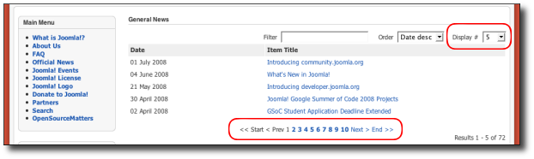
The rhuk_milkyway template provides a well-commented example for this override. The file is found here:
/templates/rhuk_milkyway/html/pagination.php
When the pagination list is required, Joomla! will look for this file in the default templates. If it is found, it will be loaded and the display functions it contains will be used.
There are four functions that can be used:
pagination_list_footer
This function is responsible for showing the select list for the number of items to display per page.
pagination_list_render
This function is responsible for showing the list of page number links as well at the Start, End, Previous and Next links.
pagination_item_active
This function displays the links to other page numbers other than the "current" page.
pagination_item_inactive
This function displays the current page number, usually not hyperlinked.

Media Files Override
This method allows 3rd party developers to override CSS and JS files that where inserted using the functions JHtml::script() or JHtml::stylesheet() and are stored inside the Joomla media folder.

Supporting Media Files Override
For this example we have a module called mod_test, this module have a CSS file installed at:
/media/mod_test/css/mystyle.css
That file should be inserted using the following functions and parameters:
JHtml::stylesheet('mod_test/mystyle.css', false, true, false);
Note that the 3rd parameter (true) is the one that makes the Joomla API to look for an override file inside your current template folder.
The override file must be placed as follow at your current template folder:
/templates/my_template/css/mod_test/mystyle.css

Cheat Sheet
Using the rhuk_milkyway template as an example, here is a brief summary of the principles we've looked at.

Customise the Component Output
To override a component layout (for example the default layout in the article view), copy:
/components/com_content/views/article/tmpl/default.php
to:
/templates/rhuk_milkyway/html/com_content/article/default.php
Read more about component output.

Customise the Module Output
To override a module layout (for example the Latest News module using the rhuk_milkyway template), copy:
/modules/mod_latest_news/tmpl/default.php
to:
/templates/rhuk_milkyway/html/mod_latest_news/default.php
Read more about module output.

Add New Module Styles
To add new module styles (chrome), add them to the following file:
/templates/rhuk_milkyway/html/modules.php
Read more about module chrome.

Customise the Pagination Links
To customise the way the items-per-page selector and pagination links display, edit the following file:
/templates/rhuk_milkyway/html/pagination.php
Read more about pagination.

Conclusion
Joomla! 1.5, through the use of an MVC paradigm has greatly improved the flexibility that is afforded to Web site designers. By way of a few simple principles, like copying certain files to certain places in your template, the designer is able to override almost all the output generated by Joomla!.

A Beginners Guide to Joomla Overrides
By Steve Burge 13 November 2012

Twitter


Making changes to Joomla's core files is often neccessary, but there's a right and a wrong way to do it.
The wrong way is to directly edit Joomla's files. If you do, you'll lose all your changes when you next update your site.
The right way is to use an override. In this post, we'll show you what overrides are and how you can use them to safely edit components, modules and languages.

An Introduction to Overrides
- What? An override is a file or database entry that is loaded instead of the normal core file.
- Where? In Joomla, overrides are nearly always placed inside your template's files.
- Who? Almost every template designer uses them. If you buy a template or download a free template, there is 99% chance that it will use overrides to help in designing your site.
- How? Read on and find out how to override modules, components and languages.

1) Module Overrides
Here's the Login Form module we're going to modify in this example. We're going to remove the Remember Me button.
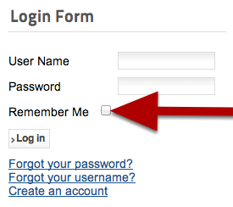
- Login to your site's files and browser to the /modules/ folder.
- Look for the /mod_login/ folder.
- Inside the /mod_login/ folder, you'll hopefully find a /tmpl/ folder. If there isn't, your module won't support overrides.
- Inside the /tmpl/ folder, look for the layout file for the module. In simple modules, it's often called default.php. Make a copy of this file.
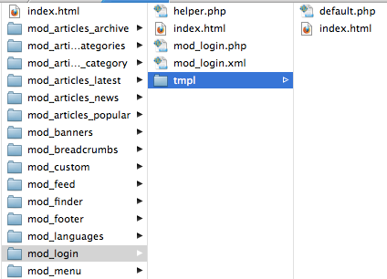
- Browse to your /templates/ folder.
- Open the folder for your current template. In this example, our template is /beez_20/.
- Open the /html/ folder.
- Inside the /html/ folder, create a new folder with the same name as your original module's folder. In this case, that's /mod_login/.
- Upload the layout file to this new folder.
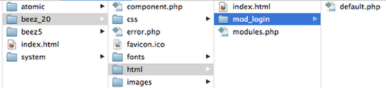
- You can now edit the layout file. In this example, comment out lines 49 to 54 from default.php.
- Save the file and your change will be visible:
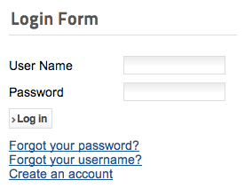

2) Component Overrides
Let's look at almost exactly the same task, but this time with a component. We're going to remove the Remember me box from our login component.
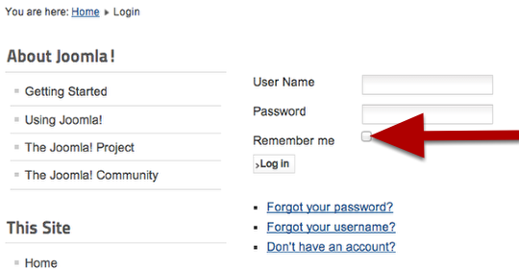
- Login to your site's files and browser to the /components/ folder.
- Look for the /com_users/ folder.
- Inside the /com_users folder, you'll hopefully find a /views/ folder. If there isn't, your components won't support overrides.
- Inside the /views/ folder, you may find several subfolders. Normally each one is logically named, according to the part of the component that they modify.
- Look inside these folders and the /tmpl/ folders they contain . Look for the layout file you want to alter. In our example, the file is /login/tmpl/default_login.php.
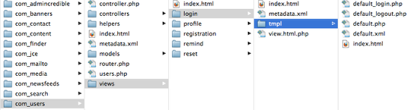
- Browse to your /templates/ folder.
- Open the folder for your current template. In this example, our template is /beez_20/.
- Open the /html/ folder.
- Inside the /html/ folder, create a new folder with the same name as your original component's folder. In this case, that's /com_users/.
- Create a subfolder inside /com_users/, matching the subfolder of the original component. In this case, that's /login/.
- Upload the layout file to this new folder.
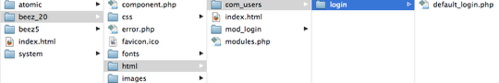
- You can now edit the layout file. In this example, comment out lines 47 to 50 from default_login.php.
- Save the file and your change will be visible:
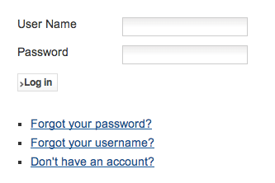

3) Language Overrides
Whereas modules and components need to be overriden via the files, you can override language on your site via the Joomla administrator.
In this example, we're going to override "Don't have an account?"
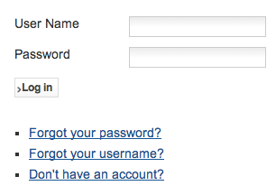
- Go to Extensions > Language Manager > Overrides.
- Click New.
- Enter "Don't have an account?" and click Search.
- You'll see the results below the search box. Click the one you want to override.
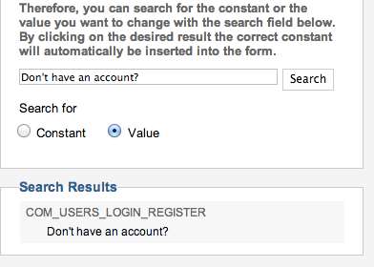
- Enter your new phrase into the Text box.
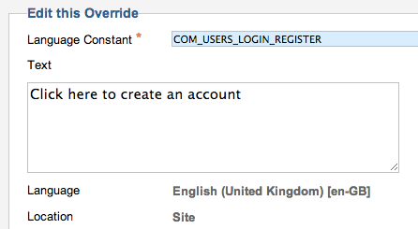
- Click Save & Close.
- You'll see the override listed as below:
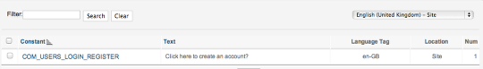
- Visit the front of your site and you'll see that override is now working:
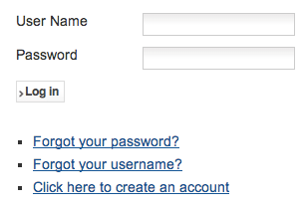

About the author

Steve is the founder of OSTraining. Originally from the UK, he now lives in Sarasota in the USA. He was a teacher for many years before starting OSTraining. Steve wrote the best-selling Drupal and Joomla books.

Customize Your Joomla Templates by Learning Overrides
Written by Joomlashack Help


Problem: Joomla "by default" Frustrations
Have you felt frustrated when you are unable to modify some "by default" positioned elements when creating a Joomla! Powered website? Well, you're not alone -- we all have been halted by elements you cannot "move" but only style. For example, what if you want to place the title at the bottom of each article instead of having it above? Or what if you want to create more divs for higher modifications and styling?

Solution: Joomla Template Overrides, w00t!
Here is the good news: Joomla allows us to create Template Overrides, which are modifications to the Joomla components or modules, that can be done from the template, and avoid hacking the Joomla! files.

Identifying your component
First of all, you need to identify what you want to change, so you'll know what file you need to override. Let's use the example of placing the article's title at the bottom.
This is the way Joomla installs its default blog (using the sample blog content and the default Protostar template from Joomla! 3.0):
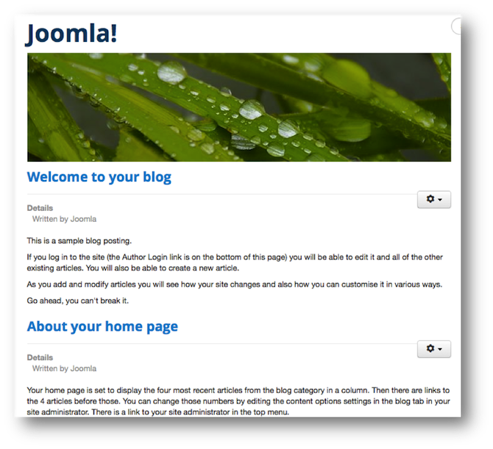
Joomla blog using default sample content
To identify the component, you need to access the menu item of that page, from the administration site, and take a closer look at the URL it has.
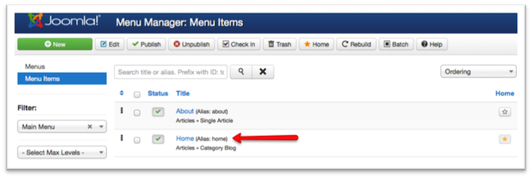
Identifying the menu item
When you enter the menu item itself, you'll notice that it has a link that brings some information about the component.
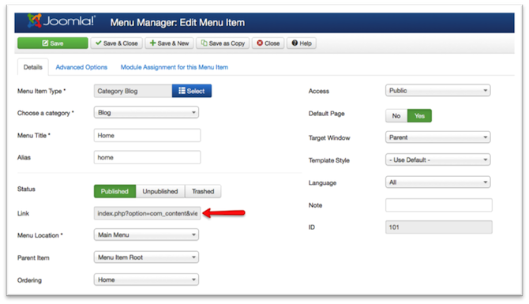
Identifying the link in the menu item
So, let's examine the link: index.php?option=com_content&view=category&layout=blog&id=9
File: index.php
Refers to the Joomla point of entry, which is common for all components
Component: option=com_content
The option parameter is saying that the component used is com_content, which is the component that manages the categories and articles of the Joomla content.
View: view=category
This means that the content component (which has many views) is using a view for presenting a category.
Layout: layout=blog
There are different layouts available for the view. In this case, it's presenting the category by using a blog layout. Sometimes the layout is not present, and it means that it is using the default layout (called "default").
Item: id=9
Lastly, this means that the category's ID is # 9. This is irrelevant for creating the override, while it's a very useful tip for understanding the Joomla database structure.

Identifying the file to be overriden
Regardless of the component, view, or layout, everything will reside in a PHP file that has a particular structure--a structure we're probably not happy with. But, when we understand the current structure, then it is really easy to identify the file you want change.
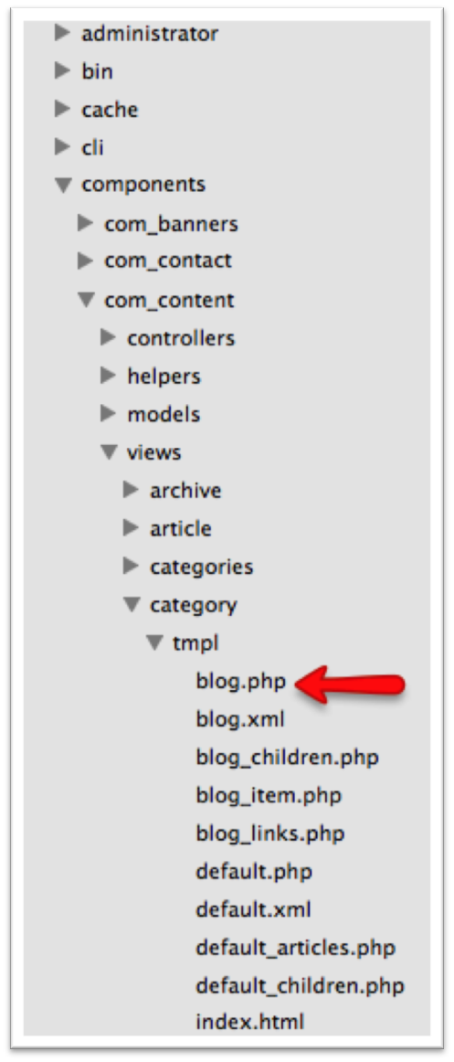
Joomla component structure from its files, identifying the blog.php file
If you explore your Joomla install, you'll notice that under the folder components, you have the com_content folder (which we identified before), and then you have the views folder, with the category folder in it (with the presentation of the category view). Then we have the tmpl folder, which contains the layouts; and finally, we have the blog.php file, which is the file we're looking for (or the starting point when there are more files that conform the layout)

Layouts with several files
In some cases, the layout may be a composite view. For example, the blog is a composite view because it has a main file for the whole blog, but it also has different files for presenting its individual parts--like each separate article. You will notice that this layout has more than one file because there are many php files in the tmpl folder that start with blog (please see the image above, we have blog.php, blog_children.php, blog_item.php, and blog_links.php).
Now, this is the part where we need to be a bit PHP savyy or use our logic the most. We want to modify each article's layout within the blog. That means that the file we need to modify is not blog.php but the file that presents each article.
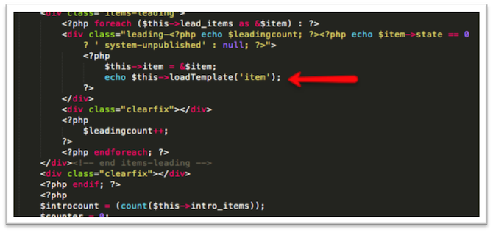
Identifying the layout file
From the PHP code, if you're not afraid of it, you can check that every time that PHP does a cycle to present the articles, it uses the code echo $this->loadTemplate('item'); which means it's using the file that presents the item (article). So, the file we want to modify is blog_item.php.

Overriding the file into our template
Now that we identified the file (of course you can explore it and do some "echo" tests to be sure it's the right file), we're going to copy this file into our template, by using the html folder and the same structure that it has in the component. In this case, it will be: html/com_content/category/blog_item.php (notice that we don't need the view or the tmpl folder here).
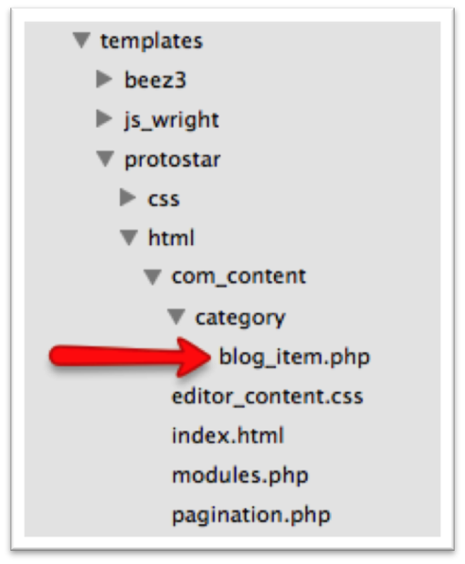
File copied to our template files
Now this new file is our override, because you will notice that if you do changes to the file (try doing a "hello world" from it), Joomla will prefer this file over the component's default file. You can start making changes at this point.

Making changes
Of course, making changes here requires basic PHP knowledge, but you will notice that simple changes are also achievable by applying simple logic and identifying the tags used in the HTML generated from Joomla.
In this case, the title is a h2 tag, that comes with an IF sentence (because it's checking if we have chosen to display the title or if it's disabled from the configuration).
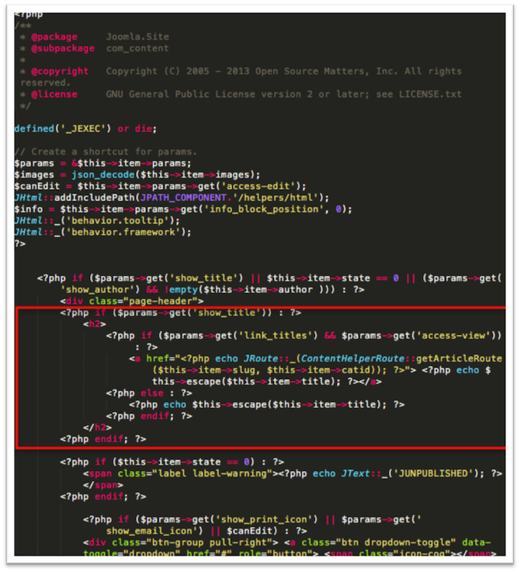
Identifying the code we want to move or change
So let's move the title all the way to the bottom (just right before the afterDisplayContent call, which is a trigger that is executed after the content is displayed, useful for plugins), and the final code will look like this:
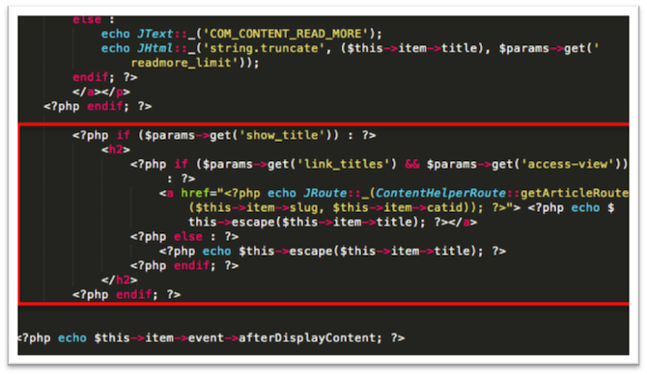
Change performed in the override file
Voila! Our site will look like this:
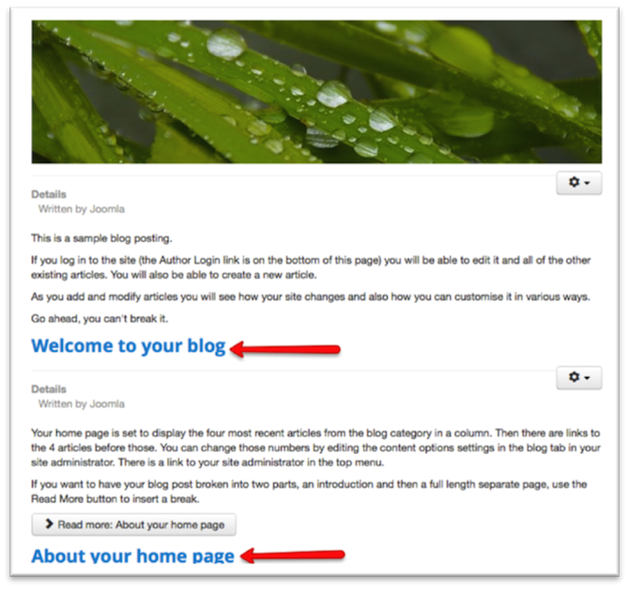
Final look of our blog after override is performed

Conclusion
In all the template and site creation process, changes may be performed at almost any level, especially when customising the components and modules. Although it's a process of trying, moving some code around and getting our hands dirty, it's a very useful to know how to make almost any change you want to your Joomla site.

